ST. ERVAN PARISH COUNCIL
Jacqui Peskett
Parish Clerk

Email: stervanpc@outlook.com
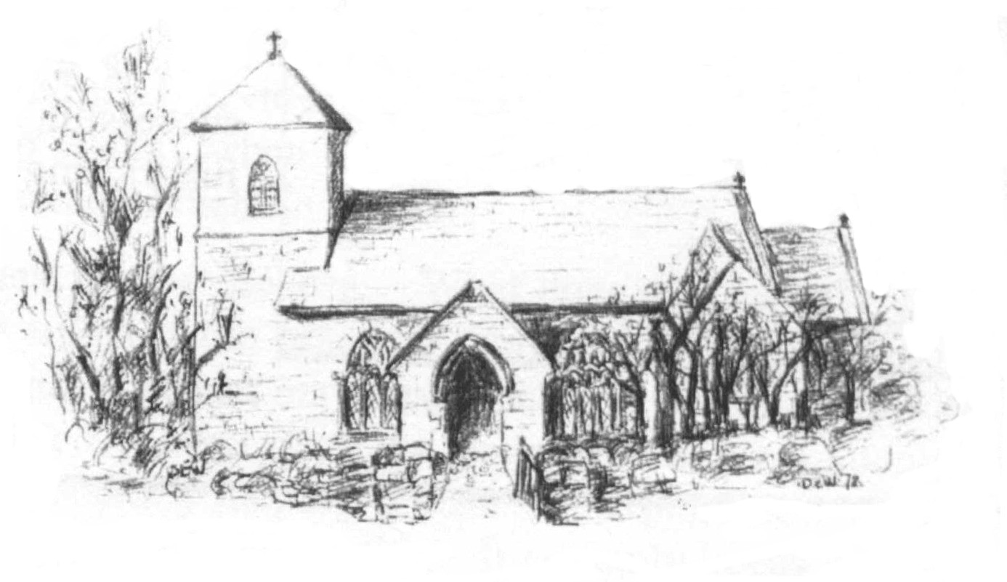

06th May 2025

I hereby give notice that the ANNUAL MEETING of ST ERVAN PARISH COUNCIL will be held at St Ervan Village Hall on Tuesday 13th May 2024 at 7.30pm

All members of the Council are herby requested to attend for the purposes of considering and resolving upon the business about to be transacted at the meeting as set out in the agenda.

Jacqui Peskett
Clerk/RFO to St Ervan Parish Council

Public Participation (15 mins)

AGENDA

Apologies and Announcements

Declarations of interest

Election of Chairman

Election of Vice Chair

Minutes of St Ervan Ordinary Parish Council Meeting 4th March 2025

Matters Arising & Correspondence

Planning Applications

Items for Information

Highways

Finance

Date Of Next Meeting: Tuesday 1st July 2025 @7.30pm

